Velocity Prediction Code:

Code should create array of distance and predicted velocity to move from a start position to an end position. Velocity to be limited to capability of hardware and accelerations restricted to fixed acceleration and deceleration rates.

Inputs:

S_Start_mm = 100;

S_Target_mm = 200;

V_max_mmpers = 16;

V_creep_mmpers = 1;

S_Creep_mm = 10;

S_Overrun_mm = 0.5;

Accel_mm_s2 = 5;

Decel_mm_s2 = -5;

S_Resolution = 0.01;

Result:

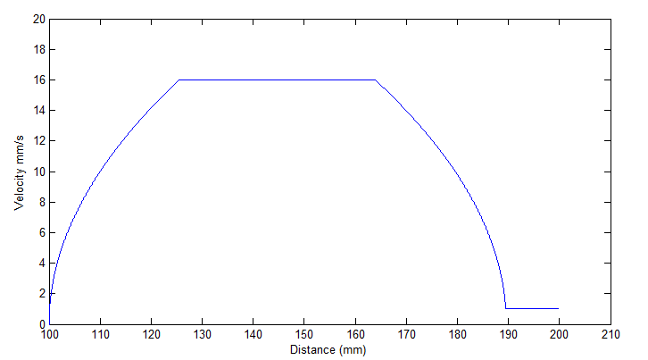

Inputs

S_Start_mm = 100;

S_Target_mm = 200;

V_max_mmpers = 16;

V_creep_mmpers = 1;

S_Creep_mm = 10;

S_Overrun_mm = 0.5;

Accel_mm_s2 = 2.5;

Decel_mm_s2 = -0.2;

S_Resolution = 0.01;

Results:

Due to slow acceleration limits, the manipulator does not reach its maximum speed limit and instead opts to decelerate to reach the target, as intended

